- Purpose
  - The purpose of this document is to describe the procedure for proper packaging and labeling of lithium-ion batteries, not contained in equipment, that are to be shipped. These will typically be replacement batteries for floor scrubbers shipped by Betco as well as battery returns to the supplier.
- Scope
  - This SOP applies to all lithium-ion batteries utilized in the GeneSys G20 and GeneSys MSAS, not contained in equipment, that are shipped from Betco. This SOP applies only to the packaging and labeling of lithium-ion batteries not contained in equipment; any procedures related to shipping are outside the scope of this SOP. The process applies to the following IDs:

E028490-EQP-0600-BE1200 – BATTERY, ROYPOW S2460A, 24V 60Ah
E028494-EQP-0600-BE1200 – BATTERY, ROYPOW S24150A, 24V 150Ah
E028495-EQP-0600-BE1200 – BATTERY, ROYPOW W24200A, 24V 200Ah

- Responsibilities
  - The operations manager/supervisor is responsible for enforcing this SOP.
- Materials
  - The proper materials needed for this process are detailed in the SOP below.
- Definitions

- Procedure
  - The first step is to obtain the correct outer packaging for the lithium-ion battery if the battery is not already fully packaged (this will typically be the case for battery returns to the supplier). If the battery is already fully packaged, skip to step 6.05 (this will typically be the case for replacement floor scrubber batteries). When the lithium-ion batteries are initially received from the supplier and removed from their outer packaging, a total of four sets of the outer packaging and associated shipping materials will be saved for each unique battery in EA203. This packaging is to be reused when shipping lithium-ion batteries, since this packaging already meets any applicable standards and codes.
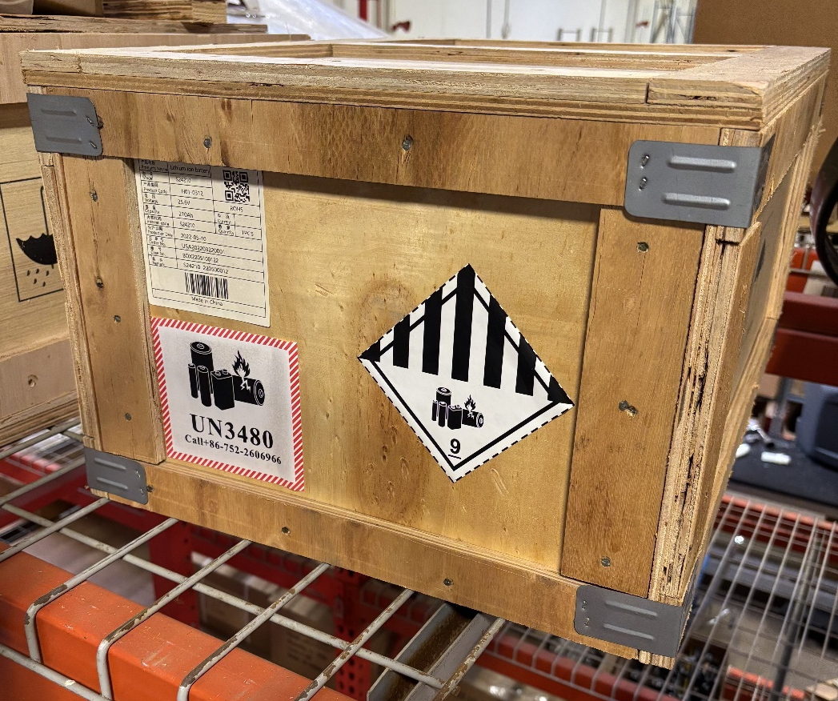
Existing Packaging from Supplier

  - Check the charge level of the lithium-ion battery. This can be done by pressing the power button on the top of the battery. For batteries with a built-in gauge, the charge level will display. For batteries without a built-in gauge, a battery meter will need to be plugged in to the battery to display the charge level. The battery must be discharged to 25% or less. If the battery has a charge of more than 25%, attach the battery to the discharge unit and discharge to proper level.
  - Place the battery into the appropriate packaging. Ensure the battery is turned off (no lights should be illuminated when power button is held down). Attach a positive and negative cap to the battery terminals (the caps will be saved from original receipt of the battery). This is to prevent short circuiting while the battery is in transit.
  - Close the package and seal it securely (see photos below).

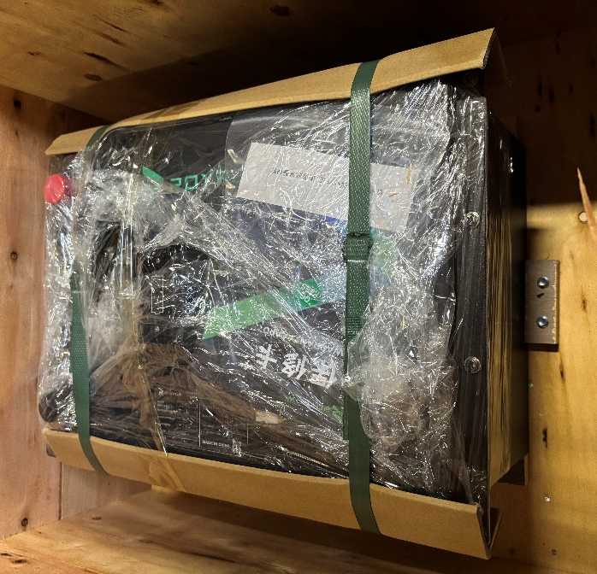
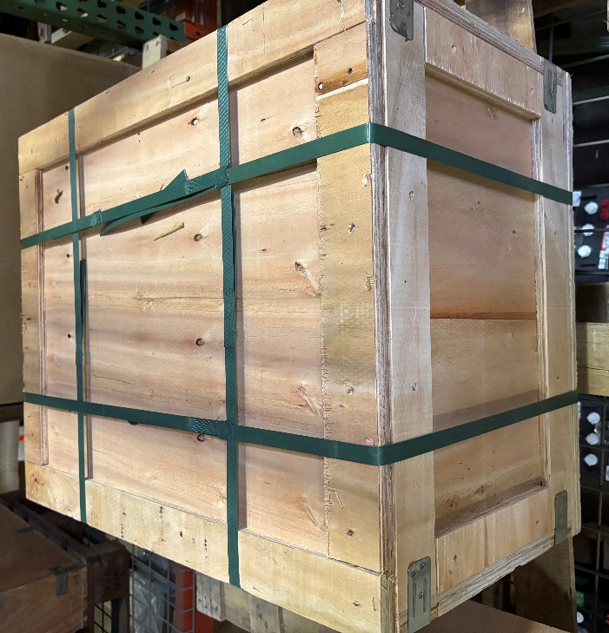
  - Remove or cover any labeling or materials from the outer packaging left over from initial shipment from the supplier.
  - Add a UN3480 Class 9 Diamond label and Cargo Aircraft Only label (examples shown below) to the outer packaging along with any other additional markings or documentation that is necessary.

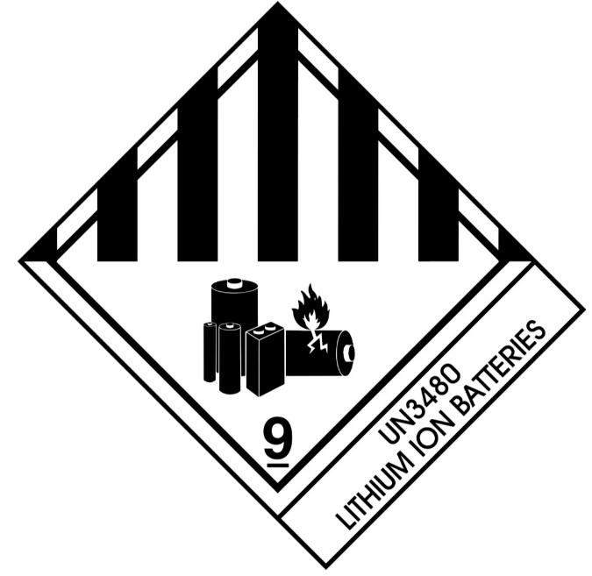
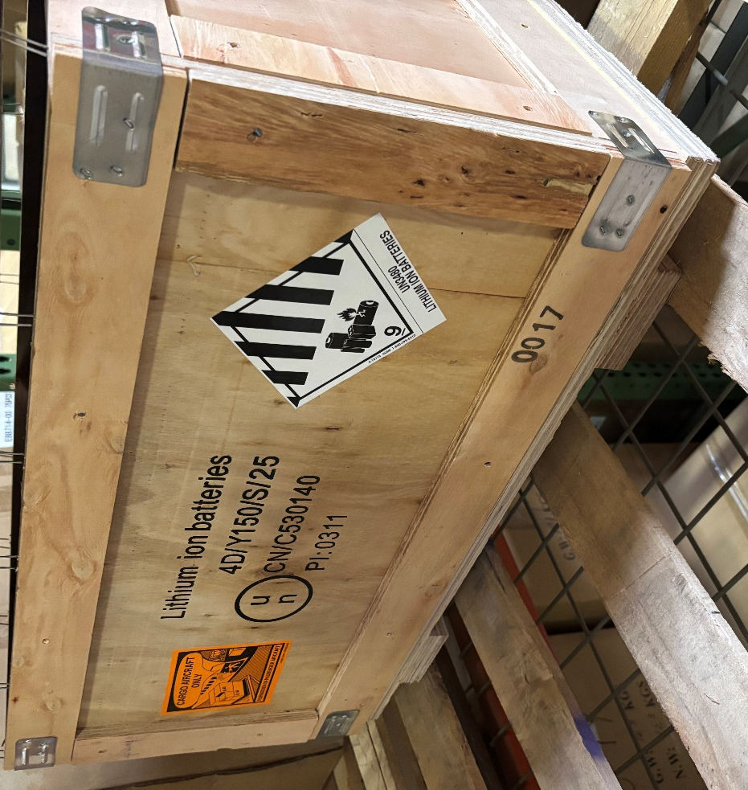
  - The lithium-ion battery is now packaged correctly and ready to ship. Follow applicable procedures or SOPs for any additional steps of the shipping process.
- References (optional section as needed)

- Training Guide

Functional Training Groups Requiring Training
Equipment Team

- SOP Change Control

Date of Change | Reason for Change
8/6/2025 | This is the first version of the S.O.P. hence there are no revisions to this document.

Approvals

Submitter/Author Approval: __________________________________ Date: ______________________

Management Approval: ______________________________________ Date: ______________________

QAU Approval: _____________________________________________ Date: ______________________

